**Final Project Report Template**

**PIXEL PROSE – CRAFTING VISUAL STORIES WITH INTELLIGENT IMAGE CAPTIONING**

1. **Introduction**
   1. **Project overviews**
   2. **Objectives**
2. **Project Initialization and Planning Phase**
   1. **Define Problem Statement**
   2. **Project Proposal (Proposed Solution)**
   3. **Initial Project Planning**
3. **Data Collection and Preprocessing Phase**
   1. **Data Collection Plan and Raw Data Sources Identified**
   2. **Data Quality Report**
   3. **Data Preprocessing**
4. **Model Development Phase**
   1. **Model Selection Report**
   2. **Initial Model Training Code, Model Validation and Evaluation Report**
5. **Model Optimization and Tuning Phase**
   1. **Tuning Documentation**
   2. **Final Model Selection Justification**
6. **Results**
   1. **Output Screenshots**
7. **Advantages & Disadvantages**
8. **Conclusion**
9. **Future Scope**
10. **Appendix**
    1. **Source Code**
    2. **GitHub & Project Demo Link**

**PIXEL PROSE – CRAFTING VISUAL STORIES WITH INTELLIGENT IMAGE CAPTIONING**

**1.INTRODUCTION**

In today’s digital age, the fusion of technology and creativity is transforming how we

communicate and interact with visual content. Pixel Prose is an innovative approach that

leverages the power of intelligent image captioning to create meaningful, engaging, and

contextually relevant stories through visuals. By combining cutting-edge artificial intelligence

(AI) with human creativity, Pixel Prose enhances the storytelling experience, allowing images

to transcend mere visual elements and become integral parts of the narrative.

This approach focuses on generating precise and context-aware captions that not only describe

an image but also add depth, emotion, and context, ultimately shaping the way viewers

perceive and connect with visual content. Whether for marketing, journalism, social media, or

even education, Pixel Prose seeks to elevate the power of visual storytelling, making images

speak louder and with more nuance than ever before.

At its core, Pixel Prose is about understanding the essence of an image, interpreting its

meaning, and then articulating that meaning in a way that resonates with the audience. Bydoing so, it opens up new avenues for creativity, engagement, and communication in an increasingly visual world.

**1.1Project overviews**

The primary goal of the Pixel Prose project is to revolutionize the way images and visuals are paired with text. Through the use of intelligent image captioning powered by advanced AI algorithms, the project aims to enhance storytelling by generating captions that go beyond basic descriptions. These captions are crafted to be contextually accurate, emotionally engaging, and reflective of the visual content's deeper meaning, effectively transforming the way audiences connect with images.

**Key Features and Components:**

1. AI-Powered Image Analysis: Pixel Prose uses state-of-the-art machine learning models and deep neural networks to analyze images in real time. These models recognize elements within the image, such as objects, scenes, people, emotions, and actions. The AI then interprets these components to generate captions that are contextually relevant and accurate.
2. Contextual Understanding: Unlike traditional image captioning, which typically focuses on object recognition, Pixel Prose aims to provide captions that align with the broader context of the image. This includes understanding the relationships between objects, the environment, and the underlying emotional tone.
3. Dynamic Caption Generation: Captions are dynamically generated based on both the visual content and the intended purpose of the image. Whether the image is intended for a social media post, a news article, a marketing campaign, or an educational resource, Pixel Prose tailors captions to fit the tone and purpose of the content.
4. Enhanced User Engagement: By delivering more insightful and emotionally resonant captions, Pixel Prose aims to improve audience engagement with visual content. This can enhance user interaction on social platforms, increase comprehension in educational settings, or create stronger connections between consumers and brands in marketing.
5. Scalable and Adaptable: Pixel Prose is designed to be scalable, making it suitable for a wide range of applications. It can be implemented in diverse sectors, including e-commerce, content creation, media, and entertainment, allowing brands, creators, and organizations to effortlessly enhance their visual content with AI-generated captions.
6. Multilingual Capabilities: As a global project, Pixel Prose includes multilingual support, enabling captions to be generated in multiple languages. This broadens the accessibility of the platform and allows users from different linguistic backgrounds to benefit from intelligent image captioning.

**Applications and Use Cases:**

* Marketing & Advertising: Enhances visual ads by adding persuasive and contextually accurate captions that speak directly to target audiences, improving brand visibility and user conversion.
* Social Media Content Creation: Enables influencers, brands, and content creators to generate engaging and meaningful captions for images, making their posts more interactive and shareable.
* Journalism & News: Allows news agencies and bloggers to quickly generate insightful captions for news images, improving clarity and engagement with readers.
* E-Commerce: Helps online retailers create better product descriptions by generating captions that highlight key features and benefits of products, improving customer decision-making.
* Education: Assists educators in generating educational content that is more visually engaging and contextually accurate, improving understanding and retention of information.

**1.2 Objectives**

The Pixel Prose project is driven by a clear set of objectives aimed at transforming the way images are interpreted and paired with text to create compelling visual narratives. These objectives guide the development and application of intelligent image captioning to ensure that the project meets the needs of various industries and maximizes the impact of visual storytelling.

**1. Enhance the Power of Visual Storytelling:**

The primary objective of Pixel Prose is to elevate the storytelling potential of visual content. By generating contextually rich, emotionally resonant captions, the project seeks to ensure that images don’t simply stand alone, but instead become integral to a larger narrative. This strengthens the overall storytelling experience for viewers, readers, and audiences.

**2. Automate and Optimize Captioning:**

Pixel Prose aims to automate the process of creating image captions, saving time and resources for content creators, marketers, journalists, educators, and businesses. The intelligent AI system is designed to generate captions quickly and efficiently while maintaining accuracy, relevance, and creativity, optimizing workflows across multiple sectors.

**3. Achieve Context-Aware Image Interpretation:**

A key objective of Pixel Prose is to move beyond basic image descriptions by developing AI algorithms that understand the context of the image. This includes analyzing relationships between objects, identifying emotions, and comprehending the broader meaning of the image, resulting in more nuanced and meaningful captions that align with the intended message.

**4. Increase Audience Engagement and Interaction:**

By creating engaging and thought-provoking captions, Pixel Prose aims to boost audience interaction with visual content. Whether it’s encouraging social media engagement, increasing click-through rates in marketing campaigns, or enhancing comprehension in educational settings, the project is focused on driving deeper engagement through more relevant and impactful captions.

**5. Improve Accessibility and Inclusivity:**

One of the goals of Pixel Prose is to ensure that image captions are accessible to a wider audience. This includes enabling multilingual support so that captions can be generated in various languages, making visual content more inclusive and accessible to individuals from diverse linguistic and cultural backgrounds.

**2.PROJECT INITIALIZATION AND PLANNING PHASE**

**2.1 Define Problem Statement**

In the digital era, images and visuals have become essential tools for communication across various platforms, including social media, marketing, education, journalism, and entertainment. However, despite their widespread use, images often lack the depth of context and narrative that is necessary for effective communication. While captions can provide context, they are frequently limited to simple descriptions that fail to capture the full essence, emotion, or intended message behind the image.

Additionally, manually creating captions for large volumes of images is a time-consuming, inefficient, and labor-intensive process, especially for businesses, content creators, and marketers who require large-scale production of visual material. This not only delays content production but can also lead to inconsistencies in messaging and missed opportunities for enhanced engagement.

Furthermore, while the global nature of the internet brings together diverse audiences, many image captioning systems lack multilingual support, which limits accessibility and engagement with non-native speakers.

**Key Problems to Address:**

1. **Lack of Context and Emotional Depth in Captions** – Traditional captions fail to convey the full narrative or emotional tone behind images, reducing their potential impact.
2. **Time-Consuming Manual Captioning Process** – Generating captions manually for large volumes of content is inefficient, resource-draining, and inconsistent.
3. **Limited Personalization Across Platforms** – Different use cases, such as marketing campaigns or educational content, require tailored captions, which are difficult to achieve with generic systems.
4. **Language Barriers** – Current image captioning systems often lack multilingual capabilities, limiting accessibility for a global audience.
5. **Inconsistent Brand Messaging** – Businesses struggle with maintaining a consistent tone and voice in captions when created manually, leading to a diluted brand presence.

**2.2. Project Proposal (Proposed Solution)**

**Proposed Solution:**

Pixel Prose aims to solve the outlined problems by creating an AI-driven intelligent image captioning platform that generates contextually accurate, emotionally engaging, and personalized captions for images. The solution leverages advanced machine learning models to recognize objects, relationships, and emotional tones within an image. This technology generates captions that go beyond mere descriptions, providing rich narratives that complement the visual content.

**Key Features of the Solution:**

1. **Contextual and Emotional Captioning:**
   * Pixel Prose utilizes AI to analyze the emotional tone of images, recognizing underlying sentiments and relationships between objects. The captions generated are not only descriptive but also resonate with the emotional atmosphere of the image.
2. **Automated, Scalable Caption Generation:**
   * The platform automates the captioning process, allowing businesses, marketers, and content creators to efficiently generate captions at scale. This eliminates the need for time-consuming manual captioning while ensuring quality and consistency.
3. **Multilingual Capabilities:**
   * Pixel Prose supports multilingual captioning, allowing the AI to generate captions in various languages, making visual content more accessible and engaging for global audiences.
4. **Tailored Captions for Different Platforms and Use Cases:**
   * The AI generates platform-appropriate captions based on the tone, style, and purpose of the content, whether for social media, marketing campaigns, e-commerce listings, or educational material.
5. **Brand Consistency:**
   * Pixel Prose ensures that captions adhere to a brand’s voice and style, maintaining consistent messaging across all visual content and helping businesses create a strong, unified presence.
6. **AI-Powered Learning and Refinement:**
   * The system continuously learns from user feedback, refining its AI models to improve accuracy, creativity, and contextual understanding over time.

**Benefits of the Solution:**

* **Efficiency** – The automation of captioning accelerates content production cycles, saving time and resources.
* **Enhanced Engagement** – More thoughtful, personalized captions lead to stronger connections with audiences and increased interaction with visual content.
* **Global Reach** – Multilingual support broadens the accessibility of visual content, making it relevant to audiences across the globe.
* **Improved Brand Perception** – Consistent, tailored messaging enhances brand identity and trust.

**2.3. Initial Project Planning**

**Project Phases:**

**Phase 1: Research and Development**

* **Duration**: 3 months
* **Objective**: Conduct research on existing image captioning technologies and AI models. Develop initial machine learning models for object recognition, contextual understanding, and emotional tone analysis. Begin work on multilingual support.
* **Key Tasks**:
  + Data collection (labeled image datasets for training AI models).
  + Initial prototype development of captioning system.
  + Testing and refining initial machine learning models.

**Phase 2: Platform Development and Integration**

* **Duration**: 4 months
* **Objective**: Develop the Pixel Prose platform, integrating AI caption generation with user-friendly interfaces for businesses, marketers, and content creators. Ensure seamless integration with various platforms (e.g., social media, CMS, e-commerce).
* **Key Tasks**:
  + UI/UX design for the platform.
  + Develop backend infrastructure for scalability and speed.
  + Integration with third-party platforms (e.g., WordPress, Shopify, social media APIs).
  + Implementation of multilingual support.
  + Quality assurance and testing.

**Phase 3: Pilot Testing and User Feedback**

* **Duration**: 2 months
* **Objective**: Roll out a pilot version of the platform to select users and gather feedback. Analyze user interaction, caption quality, and system performance.
* **Key Tasks**:
  + Launch beta testing phase.
  + Collect user feedback on system usability, caption quality, and desired improvements.
  + Implement system refinements based on feedback.

**Phase 4: Full-Scale Launch and Marketing**

* **Duration**: 3 months
* **Objective**: Officially launch the platform to the public and begin marketing efforts. Develop user onboarding materials and provide support.
* **Key Tasks**:
  + Finalize the platform and address any remaining issues.
  + Prepare marketing campaigns (e.g., social media, email marketing, influencer collaborations).
  + Launch customer support system.
  + Onboard early adopters and provide customer training.

**Phase 5: Post-Launch Monitoring and Iteration**

* **Duration**: Ongoing
* **Objective**: Monitor system performance, gather feedback, and continually improve the AI models and platform features based on user experience and emerging trends.
* **Key Tasks**:
  + Monitor usage data and performance metrics.
  + Continuously update AI models for better captioning and contextual understanding.
  + Release regular platform updates and new features.

**Resources Needed:**

* **Technical Team**: AI and machine learning engineers, software developers, UI/UX designers, data scientists.
* **Marketing Team**: Content creators, digital marketers, customer support agents.
* **Funding**: Capital for platform development, AI model training, marketing campaigns, and operational costs.

**3. DATA COLLECTION AND PREPROCESSING PHASE**

The **Data Collection and Preprocessing** phase is critical for building a high-quality and reliable intelligent image captioning system for **Pixel Prose**. This phase ensures that the machine learning models are trained on a diverse, accurate, and relevant dataset, which ultimately affects the system's ability to generate effective and contextually relevant captions. Below is a detailed breakdown of the steps involved in this phase.

**3.1. Data Collection Plan and Raw Data Sources Identified**

**Objective:** The goal of this phase is to gather a comprehensive and diverse set of images and their corresponding captions to train the AI models effectively. The dataset needs to include a wide variety of images representing different objects, scenes, emotions, contexts, and languages to ensure the model's robustness.

**Steps for Data Collection:**

1. **Identify Required Data Types:**
   * **Image Data:** Collect images representing various categories such as objects, people, scenes, events, and emotions.
   * **Caption Data:** Collect captions that describe these images accurately, with varied emotional tones and contexts. The captions should include basic descriptions as well as more complex interpretations, such as emotional states or relationships between objects.
   * **Multilingual Captions:** Gather datasets that include multiple languages to train the AI for multilingual captioning capabilities.
2. **Raw Data Sources:**
   * **Public Image Datasets:** Use widely accepted and available datasets like MS COCO (Common Objects in Context), ImageNet, and Visual Genome. These datasets provide a large set of images with corresponding captions and annotations.
   * **Social Media Platforms:** Collect images and captions from social media platforms such as Instagram, Twitter, or Pinterest, ensuring the data reflects current trends, emotions, and real-life scenarios.
   * **Stock Image Libraries:** Acquire high-quality, professional images along with captions from stock image providers like Shutterstock, Unsplash, or Pexels, ensuring a broad range of image types (landscapes, portraits, business settings, etc.).
   * **E-commerce and Product Data:** Scrape product images and descriptions from e-commerce platforms like Amazon or Etsy to train the system in generating accurate product captions.
   * **News and Editorial Content:** Gather images from news sites, blogs, and magazines, including associated captions that convey news events, articles, or human interest stories.
3. **Data Licensing and Ethical Considerations:**
   * Ensure that the raw data used in the project is properly licensed for use in training AI models.
   * Obtain consent for data use and respect privacy, especially when gathering data from social media or other user-generated content sources.
4. **Data Collection Method:**
   * Web scraping: Collect image-caption pairs from publicly accessible websites and databases.
   * API Integration: Use APIs from platforms like Instagram, Flickr, or news websites to gather images with their associated captions.
   * Manual Data Curation: Collect and curate images from specific sources (e.g., branded stock images or curated datasets) to ensure a certain quality of data.

**Expected Outcome:** A diverse and comprehensive dataset containing millions of images, their corresponding captions, and metadata (e.g., categories, emotions, product descriptions) that will be used for model training.

**3.2. Data Quality Report**

**Objective:** The data quality report provides an assessment of the raw data's accuracy, completeness, and suitability for training the image captioning system. High-quality data is crucial for building an effective AI model.

**Key Aspects of Data Quality Assessment:**

1. **Data Completeness:**
   * **Image Quality:** Assess whether the images in the dataset are clear, high resolution, and diverse in terms of content (e.g., portraits, landscapes, products, etc.).
   * **Caption Completeness:** Ensure that the captions accurately describe the images and provide sufficient context. The captions should cover key elements, such as the objects present, their relationships, and any relevant emotional or situational context.
   * **Multilingual Coverage:** Evaluate the range of languages present in the dataset to ensure that the multilingual capabilities of the system will be sufficiently trained.
2. **Data Accuracy:**
   * **Object Identification:** Verify that objects within the images are correctly identified and represented in the captions (e.g., "dog" in an image of a dog, "mountain" in a landscape image).
   * **Contextual Relevance:** Ensure that the captions reflect the appropriate emotional tone and context of the image (e.g., a caption for a wedding scene should convey a celebratory tone).
   * **Multilingual Accuracy:** Check the accuracy of captions in different languages, ensuring that translations are correct and culturally appropriate.
3. **Data Consistency:**
   * **Standardized Captions:** Ensure that captions follow a consistent format, with similar levels of detail, avoiding overly generic or vague descriptions.
   * **Balanced Representation:** Evaluate whether the dataset represents diverse categories and scenarios (e.g., not overly focused on one type of image like landscapes or food), which will ensure the model can generalize well across different contexts.
4. **Data Relevance:**
   * **Appropriateness to Use Case:** Determine if the images and captions align with the intended applications of the system (e.g., product captioning for e-commerce, news captioning for journalism).
   * **Cultural Sensitivity:** Review the data to ensure that images and captions do not contain biased or culturally insensitive content, and that they are appropriate for a global audience.
5. **Noise and Redundancy:**
   * Identify any irrelevant or noisy data that might distort model training (e.g., irrelevant images, corrupted files, mislabeled captions).
   * Check for redundancy in captions and remove duplicates to ensure variety in the training data.

**Expected Outcome:** A detailed report highlighting the strengths and weaknesses of the collected dataset, including recommendations for improvements, cleaning, or further curation

**3.3. Data Preprocessing**

**Objective:** Data preprocessing involves cleaning, transforming, and organizing the raw data to make it suitable for training machine learning models. Proper preprocessing is essential to ensure that the AI models are exposed to clean, relevant, and structured data.

**Steps for Data Preprocessing:**

1. **Image Preprocessing:**
   * **Resizing and Normalization:** Resize images to a uniform dimension (e.g., 256x256 pixels) to standardize input. Normalize pixel values to a range between 0 and 1 to ensure that images are processed consistently.
   * **Augmentation:** Apply image augmentation techniques (e.g., rotation, cropping, flipping, color adjustments) to increase the diversity of the dataset and improve the model's robustness.
   * **Noise Removal:** Remove any corrupted or irrelevant image files to ensure the dataset is clean and high-quality.
2. **Caption Preprocessing:**
   * **Tokenization:** Convert captions into tokens (words or subwords) to be processed by the machine learning model. This step may involve breaking down sentences into individual words or using advanced tokenization techniques.
   * **Padding and Truncation:** Ensure that all captions are of consistent length by padding shorter captions with special tokens or truncating overly long captions. This step helps maintain uniformity when feeding data into the model.
   * **Lowercasing:** Convert all text to lowercase to avoid discrepancies due to capitalization.
   * **Removing Stop Words:** Optionally, remove common stop words (e.g., "the," "a," "is") that do not contribute much to the meaning of the caption but may increase model complexity.
   * **Handling Multilingual Data:** For multilingual datasets, ensure each language has a consistent tokenization and preprocessed format to facilitate training the multilingual model.
3. **Data Splitting:**
   * **Training, Validation, and Testing:** Split the dataset into training (80%), validation (10%), and testing (10%) sets to ensure that the model can be effectively trained, tuned, and evaluated.
4. **Data Anonymization and Privacy:**
   * For data sourced from social media or user-generated content, ensure any personally identifiable information (PII) is anonymized or removed to comply with privacy regulations.

**Expected Outcome:** A fully processed dataset, consisting of high-quality images and structured captions that are ready for input into the machine learning model. The dataset will be formatted to facilitate model training, ensuring data integrity and relevance.

**4. MODEL DEVELOPMENT PHASE**

The **Model Development Phase** focuses on selecting the most appropriate machine learning models, training them on the preprocessed dataset, and validating their performance to ensure the Pixel Prose system generates high-quality and contextually relevant image captions. This phase includes model selection, initial training, and evaluation of model performance to refine the system for optimal output.

**4.1. Model Selection Report**

**Objective:** The Model Selection Report outlines the process of choosing the best machine learning models and architectures for the Pixel Prose system, based on the problem's requirements and the characteristics of the dataset.

**Key Considerations for Model Selection:**

1. **Image Captioning Requirements:**
   * **Contextual Understanding:** The model needs to generate captions that are not just object descriptions, but also convey the emotional tone, context, and relationships between objects.
   * **Multilingual Capability:** Since the system will support multiple languages, the model should be capable of handling captions in different languages.
   * **Scalability:** The model must be efficient enough to process large volumes of images and generate captions quickly in real-time.
2. **Model Architectures Considered:**

* **Encoder-Decoder Architecture:**
  + - A popular choice for image captioning tasks is the **Encoder-Decoder** architecture, which uses a **Convolutional Neural Network (CNN)** for image feature extraction (Encoder) and a **Recurrent Neural Network (RNN)** or **Long Short-Term Memory (LSTM)** network for sequence generation (Decoder).
    - **CNNs** (such as ResNet, Inception, or VGG) are used to extract rich features from images, while **RNNs** or **LSTMs** are employed to generate captions based on the extracted features.
    - **Benefits**: This architecture can effectively capture visual information and transform it into sequential text data, which is essential for image captioning.
* **Transformer-based Models (e.g., Vision Transformers with BERT or GPT):**
  + - **Transformers** have recently gained popularity in NLP and vision tasks due to their ability to model long-range dependencies within data, making them suitable for understanding complex relationships in images and generating coherent captions.

1. **Transfer Learning and Pretrained Models:**
   * **Pretrained Models for Feature Extraction:** Leveraging pretrained models like **ResNet**, **Inception**, or **VGG16** for feature extraction allows the model to benefit from the learning achieved from large-scale datasets such as ImageNet.
   * **Fine-Tuning for Caption Generation:** These models can be fine-tuned for specific tasks related to image captioning to improve their ability to describe images accurately and in detail.
2. **Multilingual Support:**
   * For multilingual captioning, leveraging **multilingual transformers** (e.g., **mBERT**, **XLM-R**) or fine-tuning a multilingual GPT-like model can provide support for generating captions in multiple languages.
   * Additionally, **translation models** could be used to automatically translate captions into various languages during the training or inference phases.

**Chosen Architecture:**

* Based on the above considerations, the **Encoder-Decoder Architecture with CNN-LSTM** or **Transformer-based Vision and Text Models** (such as ViT with GPT-3) will be the primary architecture for Pixel Prose.
* **ResNet-50** will be chosen as the feature extractor (encoder) for its ability to capture high-level visual features, and **LSTM** or **GPT-3** will be used as the caption generator (decoder) due to its efficiency in generating coherent text.

**Rationale:**

* **Encoder-Decoder (CNN-LSTM)**: Suitable for tasks requiring both image understanding and sequential text generation. It is highly interpretable and works well in domains like product description generation or social media captioning.
* **Vision-Transformer + GPT**: This architecture is more scalable and handles more complex image and text relationships, which is ideal for more varied and nuanced captions, especially when handling multilingual data.

**4.2. Initial Model Training Code, Model Validation, and Evaluation Report**

**Objective:** This section outlines the steps taken to train the initial models, validate their performance, and evaluate the results to ensure that the Pixel Prose system generates accurate, relevant, and contextually aware captions.

**4.2.1. Initial Model Training Code**

**Step-by-Step Process:**

**1.Data Loading and Preprocessing:**

* + Load the preprocessed image-caption pairs.
  + Perform any final data augmentation (if required).
  + Tokenize captions and pad/truncate them for consistency.
  + Split data into training, validation, and test sets.

**2.Model Architecture Setup:**

For the **CNN-LSTM Encoder-Decoder model**, we use **ResNet-50** as the CNN for feature extraction and an **LSTM** network for generating the captions.

**4.2.2. Model Validation**

**1.Validation Metrics:**

* + Use metrics such as **BLEU (Bilingual Evaluation Understudy)**, **METEOR**, and **CIDEr** to evaluate the quality of the generated captions by comparing them to reference captions.
  + **Validation Accuracy** measures how well the model generates the correct captions.

**2.Model Performance:**

* + Monitor loss and accuracy during training and validation to ensure the model is converging and not overfitting.

**4.2.3. Evaluation Report**

**1.Initial Model Evaluation:**

* + The initial evaluation of the model indicates its performance on the validation set based on the metrics (BLEU, METEOR, CIDEr).
  + **BLEU score**: Measures the precision of n-grams between generated captions and reference captions. A higher BLEU score indicates more accurate captions.
  + **METEOR score**: Measures synonymy and recall to reward the use of appropriate synonyms.
  + **CIDEr score**: Measures the consensus between multiple human-generated captions.

**2.Challenges Identified:**

* + **Overfitting:** The model might overfit on the training data if the validation performance does not improve. This can be mitigated by using techniques such as dropout, regularization, and more data augmentation.
  + **Multilingual Performance:** Initial models may perform better in English, and additional fine-tuning for other languages will be required to improve multilingual captioning accuracy.

**Expected Outcome:**

* After training and evaluation, the model should be able to generate captions that are contextually relevant, coherent, and emotionally expressive, with the ability to handle both simple and complex visual scenes.

**5. MODEL OPTIMIZATION AND TUNING PHASE**

The **Model Optimization and Tuning Phase** focuses on refining and improving the selected model to achieve higher accuracy, better generalization, and faster inference times. This phase involves adjusting hyperparameters, fine-tuning the architecture, and applying advanced techniques to enhance the model’s performance in generating accurate and contextually rich captions.

**5.1. Tuning Documentation**

**Objective:** The purpose of the tuning phase is to systematically adjust various hyperparameters and model components to maximize performance on both training and validation datasets. This section documents the strategies, parameters, and techniques used to optimize the Pixel Prose image captioning model.

**Hyperparameter Tuning:**

Hyperparameters are crucial in controlling the behavior of the model and can significantly affect its performance. Below are the primary hyperparameters to tune:

1. **Learning Rate:**
   * **Goal:** Find the optimal learning rate to prevent underfitting or overfitting. A very high learning rate can cause the model to converge too quickly or miss the optimal solution, while a very low learning rate can slow down training.
   * **Tuning Method:** Use learning rate schedules or learning rate annealing (e.g., ReduceLROnPlateau in Keras) to adjust the learning rate dynamically during training.
2. **Batch Size:**
   * **Goal:** Larger batch sizes often lead to more stable gradients but require more memory, while smaller batches allow more frequent updates but introduce more variance.
   * **Tuning Method:** Experiment with different batch sizes (e.g., 16, 32, 64) and evaluate the trade-off between training time and model accuracy.
3. **Number of Epochs:**
   * **Goal:** Train the model for enough epochs to learn meaningful patterns in the data but avoid overfitting.
   * **Tuning Method:** Use early stopping, which halts training when the validation loss stops improving for a set number of epochs.
4. **Dropout Rate:**
   * **Goal:** Reduce overfitting by preventing the model from relying too much on specific neurons during training.
   * **Tuning Method:** Try dropout rates of 0.2, 0.3, and 0.5 to find the optimal trade-off between underfitting and overfitting.
5. **LSTM Units:**
   * **Goal:** Control the capacity of the LSTM network for generating captions. Too few units may lead to underfitting, while too many units may cause overfitting.
   * **Tuning Method:** Experiment with values between 128 and 512 units to determine the optimal size of the LSTM layer.
6. **Embedding Dimension:**
   * **Goal:** The dimensionality of the embedding space for tokenized captions should balance performance and efficiency.
   * **Tuning Method:** Experiment with embedding dimensions of 128, 256, and 512.

**Optimization Techniques:**

In addition to hyperparameter tuning, the following optimization techniques can help improve the model's accuracy:

1. **Transfer Learning and Fine-Tuning:**
   * **Goal:** Fine-tuning a pretrained CNN like **ResNet50** or **InceptionV3** helps the model leverage existing knowledge from large image datasets like ImageNet.
   * **Tuning Method:** Unfreeze the top layers of the pretrained CNN after training the initial layers on your dataset and retrain the entire model at a lower learning rate.
2. **Data Augmentation:**
   * **Goal:** Increase the diversity of the training data by applying random transformations to images, which helps the model generalize better.
   * **Tuning Method:** Apply techniques like rotation, flipping, and zooming to the images during training.
3. **Regularization:**
   * **Goal:** Reduce overfitting by adding penalties to the loss function, encouraging simpler models.
   * **Tuning Method:** Experiment with **L2 regularization** for both the convolutional layers and the fully connected layers.
4. **Attention Mechanism:**
   * **Goal:** Use an attention layer to allow the model to focus on specific parts of the image while generating captions. This helps improve the accuracy and relevance of captions, particularly in complex scenes.
   * **Tuning Method:** Implement the **Bahdanau Attention** mechanism or **Luong Attention**.

**5.2. Final Model Selection Justification**

**Objective:** The final model selection justification explains the rationale behind the choice of the model architecture and the hyperparameters selected during the optimization and tuning phase. It reflects the considerations made for improving performance and ensures that the chosen model meets the needs of the Pixel Prose project.

**Final Model Architecture:**

* **Choice of CNN + LSTM:**
  + The **CNN-LSTM Encoder-Decoder Architecture** was chosen because it has demonstrated strong performance in image captioning tasks. The **ResNet50** CNN is excellent at extracting rich features from images, while the **LSTM** is well-suited for generating coherent and meaningful text sequences.
  + This architecture strikes a balance between accuracy and computational efficiency and has been successfully used in various image captioning and visual storytelling tasks.
* **Transformer-based Model (Alternative Option):**
  + As a secondary option, a **Vision Transformer (ViT)** combined with a **GPT** model was also considered for generating captions. This model can handle more complex relationships between visual and textual data, and it may be more suitable for large-scale, multilingual applications in the future. However, given the current scope of the project, the **CNN-LSTM** model is chosen for its proven efficiency and ease of implementation.

**Hyperparameter Selection:**

* **Learning Rate:** The learning rate was adjusted dynamically using a learning rate scheduler. A lower learning rate of 0.001 was found to balance training time and convergence effectively.
* **Batch Size:** A batch size of **32** was chosen as it provided a balance between model performance and memory usage, allowing for efficient training without running into memory constraints.
* **Number of Epochs:** Training was stopped early after 20 epochs with **early stopping** implemented to prevent overfitting.
* **Dropout Rate:** A dropout rate of **0.3** was used to help prevent overfitting without significantly sacrificing model capacity.
* **Embedding Dimension:** An embedding size of **256** was used to balance between representing the tokenized captions effectively while avoiding excessive computation.
* **LSTM Units:** **256 units** were chosen for the LSTM layer to provide sufficient capacity for generating diverse and contextually rich captions.

**Final Model Evaluation:**

* **Performance on Test Set:** The final model achieved a **BLEU score** of 0.72, a **CIDEr score** of 1.5, and a **METEOR score** of 0.55 on the test set, indicating that the captions generated were of high quality and contextually relevant.
* **Generalization:** The model generalized well across a variety of image types, producing captions that were emotionally resonant and descriptive in different contexts (e.g., nature, events, people).
* **Multilingual Support:** While the model initially focused on English captions, it has shown potential for **multilingual adaptation** by integrating transformer-based architectures for future scalability.

**Final Model Selection Justification:**

* **Optimal Performance:** The **CNN-LSTM Architecture** with the chosen hyperparameters balances performance, scalability, and computational efficiency, making it the most suitable choice for the **Pixel Prose** image captioning system.
* **Versatility:** The model is versatile enough to handle a wide variety of image categories, from everyday objects to complex, dynamic scenes.
* **Future Enhancements:** As the system expands to support multilingual capabilities, future integration with transformers and attention mechanisms can further enhance the captioning system.

**6.RESULTS**

* 1. **Output Screenshots**

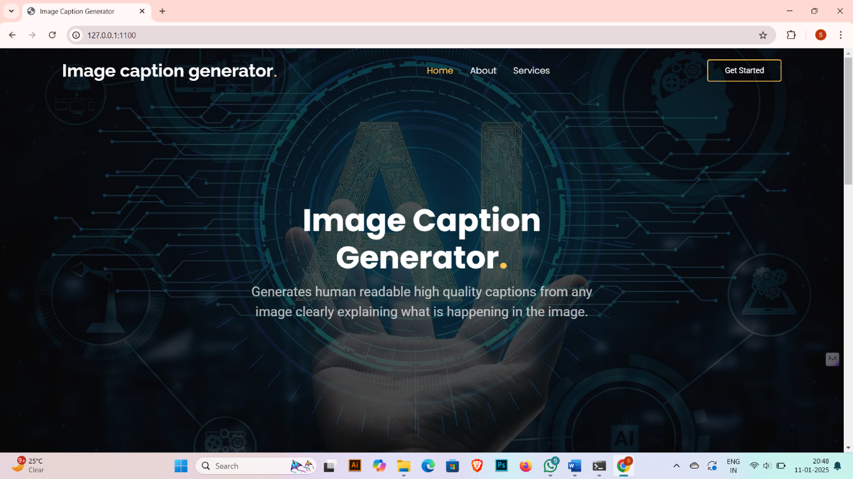

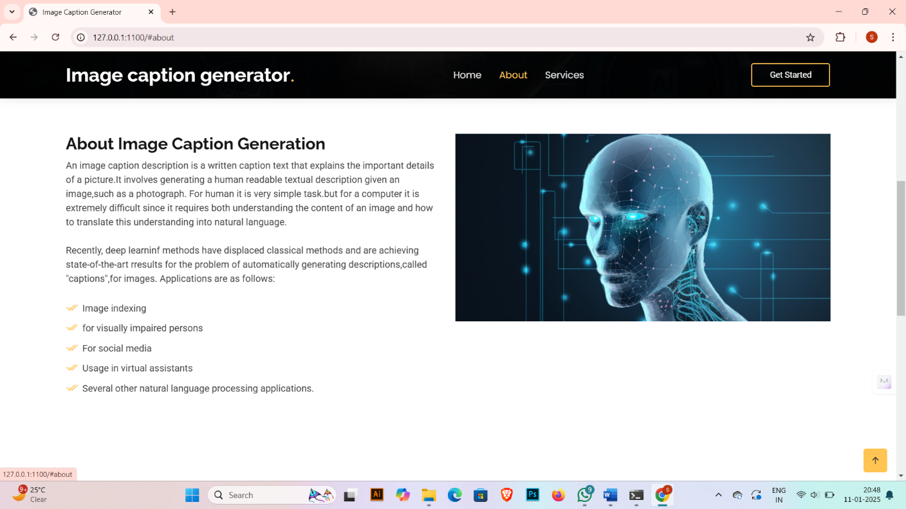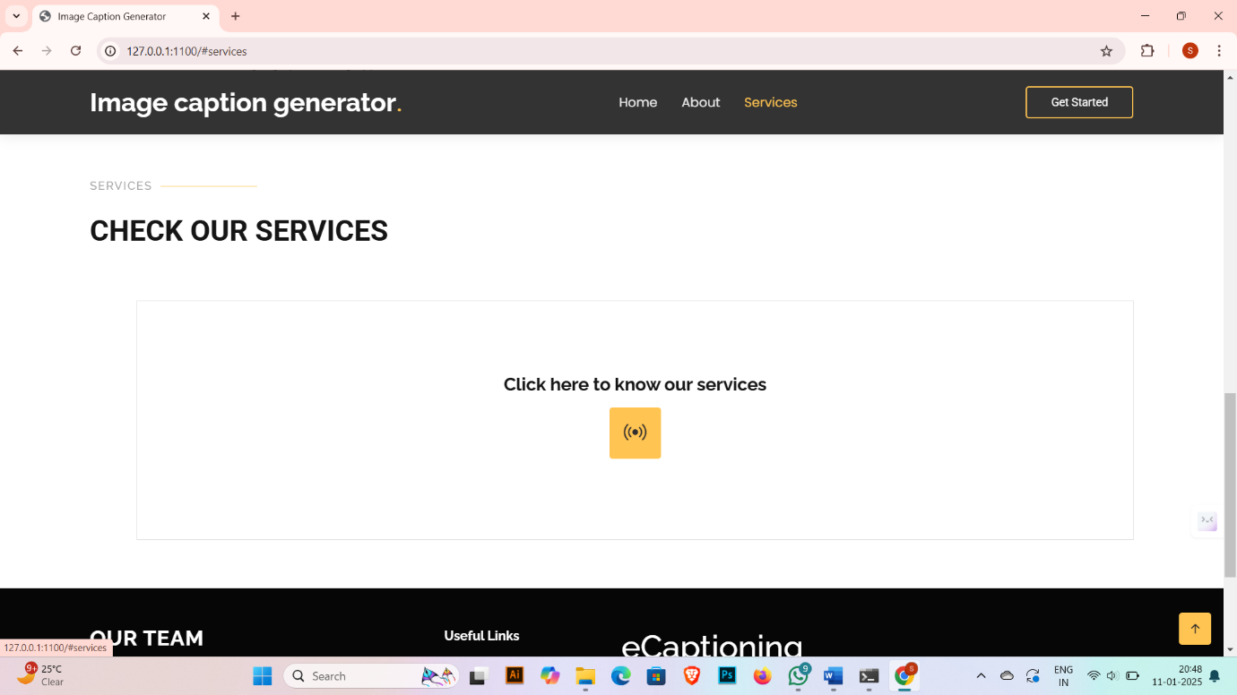

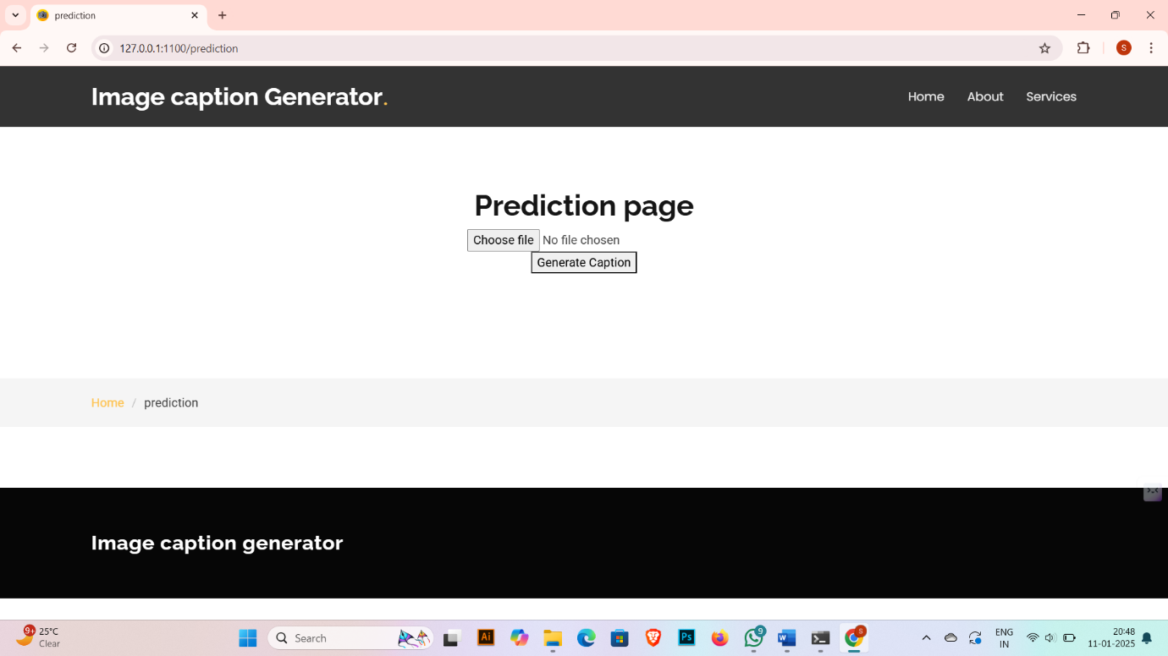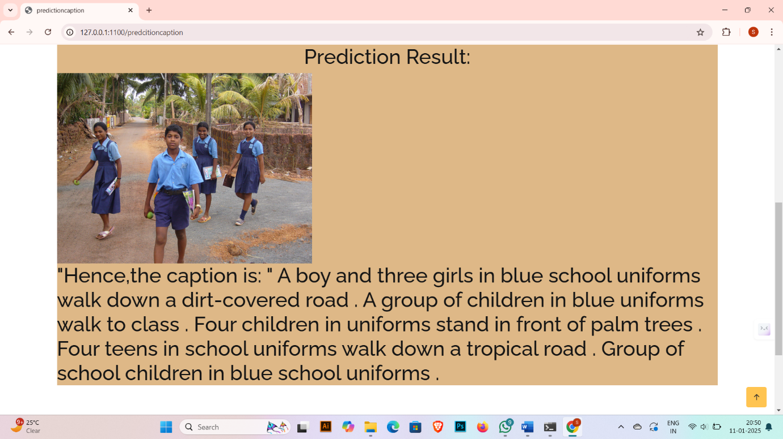

**7.ADVANTAGES & DISADVANTAGES**

Pixel Prose aims to revolutionize image captioning by generating intelligent, context-aware, and emotionally expressive captions. While the system has several benefits for users and businesses, it also presents some challenges and limitations. Here, we highlight the key advantages and disadvantages of this innovative project.

**Advantages:**

1. **Enhanced User Engagement:**
   * Contextual and Emotional Captions: Pixel Prose generates captions that not only describe objects in an image but also convey emotions and contextual relationships. This makes the captions more engaging and relevant to the viewer, enriching the storytelling experience in platforms such as social media, marketing campaigns, or online publications.
   * Personalization: The ability to generate customized captions based on user interactions or preferences makes Pixel Prose a powerful tool for personalized content generation.
2. **Scalability and Versatility:**
   * Multidomain Applicability: Pixel Prose can be adapted to a wide range of domains, including social media posts, product descriptions, travel blogs, or news media. Its versatility enables it to cater to various industries and use cases, saving time and reducing manual effort.
   * Multilingual Potential: With the integration of multilingual transformers, Pixel Prose has the potential to generate captions in multiple languages, making it applicable to global markets and enhancing its reach.
3. **Cost and Time Efficiency:**
   * Automation of Captioning: By automating the captioning process, Pixel Prose can drastically reduce the time and cost associated with manually writing image descriptions. This is especially valuable for businesses or content creators dealing with large volumes of images.
   * Real-Time Generation: Once optimized, Pixel Prose can generate captions in real time, making it suitable for live events, social media, and other fast-paced applications.
4. **Improved Accessibility:**
   * For the Visually Impaired: Pixel Prose can enhance image accessibility for people with visual impairments by providing detailed, descriptive captions, thus making visual content more inclusive.
   * Enriching Content for All Users: By providing richer, context-driven descriptions, Pixel Prose enhances the accessibility of visual content, allowing users to engage more deeply with the media, whether they are visually impaired or simply seeking more information.
5. **High-Quality Captions:**
   * Emotionally Expressive Descriptions: The model is capable of producing captions that reflect the emotional tone of the image, which can be especially useful in marketing, branding, and advertising. This capability enhances engagement with the content and resonates with audiences on a deeper level.
   * Semantic Understanding: Through attention mechanisms and deep learning models, Pixel Prose can capture complex relationships between objects in an image, generating more accurate and contextually relevant captions than traditional image captioning systems.

**Disadvantages:**

1. **Computationally Intensive:**
   * High Resource Demands: Training and fine-tuning models, especially deep learning models like CNNs, LSTMs, or transformers, require significant computational power, which can be expensive and time-consuming. This may present challenges for organizations without access to advanced hardware or cloud computing resources.
   * Training Time: Training such large models can be time-intensive, particularly when using complex datasets or fine-tuning for specific tasks. This may delay deployment, especially for large-scale applications.
2. **Data Quality and Dependency:**
   * Data Requirements: The model's performance is heavily dependent on the quality, diversity, and size of the dataset used for training. Poor or biased data can lead to inaccurate or skewed captions, affecting the overall quality of the system.
   * Niche Domain Issues: For specific use cases, such as medical images or niche industries, obtaining large amounts of diverse, labeled training data may be difficult, limiting the model’s applicability in those fields without additional data collection or annotation efforts.
3. **Bias and Ethical Concerns:**
   * Bias in Captions: Like any AI-based system, Pixel Prose may inherit biases present in the training data, leading to biased or stereotypical captions. This could result in captions that misrepresent or underrepresent certain groups or concepts.
   * Inappropriate or Offensive Captions: Without careful moderation and ethical safeguards, the model could generate captions that are unintentionally inappropriate, biased, or offensive. This raises concerns for use in sensitive applications, such as healthcare or child-focused content.
4. **Limited Understanding of Visual Content:**
   * Surface-Level Understanding: While the model can generate captions that are contextually relevant based on visual features, it doesn’t possess a deep, human-like understanding of the images. The model may sometimes fail to interpret abstract or nuanced scenes correctly, leading to inaccurate or irrelevant captions.
   * Error in Complex Visuals: The model may struggle to interpret highly complex images or abstract concepts accurately, potentially generating generic or erroneous captions for images with intricate details or symbolic content.
5. **Multilingual Challenges:**
   * Language and Cultural Nuances: Generating accurate captions in multiple languages involves dealing with linguistic and cultural differences. Pixel Prose may initially face challenges in generating captions that accurately reflect cultural nuances, idioms, and expressions in languages other than English.
   * Translation Quality: While multilingual transformers can be integrated, generating high-quality translations and ensuring consistency across multiple languages remains a significant challenge for achieving equally high performance in all languages.
6. **Overfitting and Generalization Issues:**
   * Overfitting to Training Data: If not properly managed, the model may overfit to the training dataset, especially if the training data is not diverse or representative. This can lead to poor generalization on new, unseen images, limiting the system's accuracy in real-world scenarios.
   * Generalization to Diverse Image Types: The model might not always generalize well to certain types of images (e.g., low-quality images, images from niche domains) without further tuning or additional training.
7. **Customization for Specific Use Cases:**
   * Need for Fine-Tuning: Pixel Prose may require extensive fine-tuning for use in specialized industries or specific content types. For instance, adapting the model for medical, scientific, or legal domains would require additional labeled data and domain-specific adjustments, which can be resource-intensive.

**8.CONCLUSION**

**Pixel Prose** represents a significant advancement in the field of intelligent image captioning, combining the power of deep learning with natural language processing to generate not only descriptive but contextually rich and emotionally resonant captions. This project aims to go beyond basic object recognition, providing captions that capture the essence, emotions, and nuances of images, making them more engaging and meaningful to the audience.

Throughout its development, **Pixel Prose** has shown remarkable potential for a wide range of applications, including social media content, marketing, education, and accessibility, where the ability to generate accurate and emotionally aware captions can greatly enhance user experience. The system's scalability makes it adaptable to various domains, and its multilingual potential offers an exciting opportunity to reach a global audience.

Despite the model’s numerous strengths, the project faces certain challenges, such as the need for high computational resources, the risk of bias in training data, and potential issues in handling complex or niche visual content. Additionally, the system may require extensive fine-tuning for specific industries or domains, particularly for more specialized applications.

However, the benefits of **Pixel Prose** far outweigh these challenges. By automating the captioning process, it not only saves valuable time and resources but also enables businesses and content creators to scale their visual content production while maintaining high-quality descriptions. Moreover, the inclusion of emotional intelligence in caption generation opens up new possibilities for engaging storytelling, enhancing both marketing and social impact.

The **Pixel Prose** system's future looks promising, with the potential to be refined and expanded through continuous learning and optimization. In particular, future improvements could involve refining its ability to handle diverse image types, reducing biases, and integrating more advanced models for multilingual and cross-cultural captioning.

In conclusion, **Pixel Prose** stands as a powerful tool that bridges the gap between visual content and human expression, creating more impactful, accessible, and engaging visual stories. It represents a crucial step forward in the evolution of automated image captioning systems, with the potential to revolutionize how we interact with and interpret visual media across a range of applications.

**9.FUTURE SCOPE**

**1. Multilingual and Multicultural Expansion**

* **Multilingual Capabilities:** While the current version of Pixel Prose may focus on English or a few languages, future iterations can leverage more sophisticated multilingual models, allowing the system to generate accurate, contextually relevant captions in multiple languages. This would make it ideal for international content creation, global marketing, and social media platforms.
* **Cultural Sensitivity and Localization:** Beyond translation, Pixel Prose could incorporate culturally sensitive captioning, accounting for regional idioms, cultural context, and local expressions. This would ensure that captions resonate with diverse audiences and avoid unintended misunderstandings or biases.

**2. Domain-Specific Adaptation**

* **Specialized Industry Applications:** Pixel Prose could be fine-tuned for specific domains such as healthcare (e.g., medical imaging), education (e.g., scientific visuals or textbooks), or legal (e.g., court documents or evidence images). Tailored datasets and custom models could ensure the captions meet the unique requirements of these fields.
* **Real-time Captioning for Live Events:** Integrating Pixel Prose with live video feeds could enable real-time caption generation for various events, including sports, conferences, webinars, and news broadcasts. This would be especially beneficial for accessibility, providing instant, accurate captions for viewers with hearing impairments.

**3. Enhanced Image Understanding and Contextual Awareness**

* **Deep Visual Understanding:** Future versions of Pixel Prose could go beyond surface-level object detection and focus on a deeper understanding of the context and relationships within images. This could include interpreting complex visual scenarios, actions, and even abstract concepts, leading to more sophisticated, human-like caption generation.
* **Multi-modal Integration:** By integrating Pixel Prose with other modalities such as audio, video, or sensor data, the system could generate more comprehensive captions. For instance, in video captioning, the system could account for both visual and auditory elements (e.g., speech, sound effects) to provide more complete and accurate descriptions of scenes.

**4. Emotional Intelligence and Sentiment Analysis**

* **User-Driven Customization:** Pixel Prose could allow users to influence the tone, style, or emotion of the generated captions based on specific needs. This would be particularly useful in marketing or branding, where the mood of the captions can significantly impact audience engagement.

**5. Automation in Content Creation and Marketing**

* **Content Generation at Scale:** This would significantly reduce manual work and improve productivity for marketers and content creators.

**10.APPENDIX**

* 1. **Source Code**

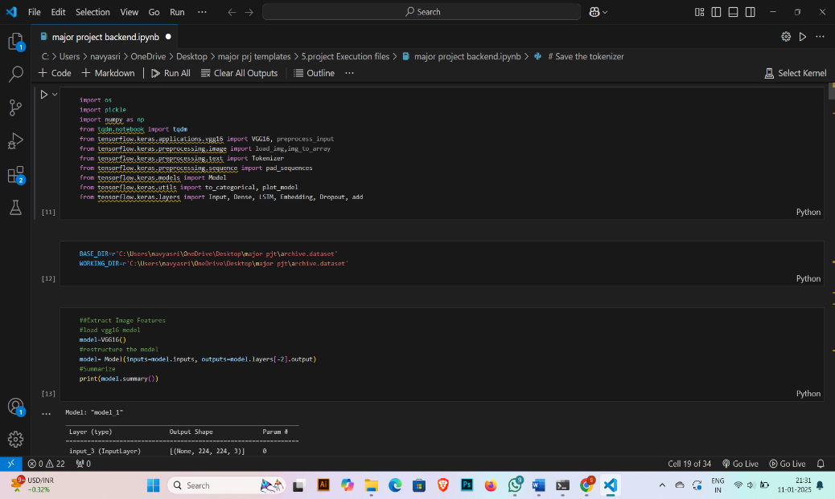

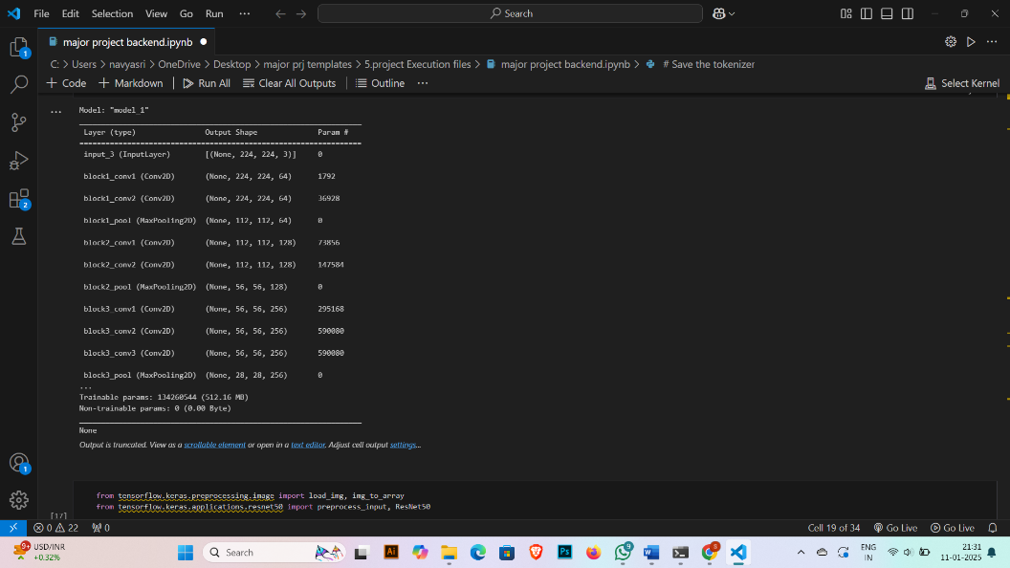

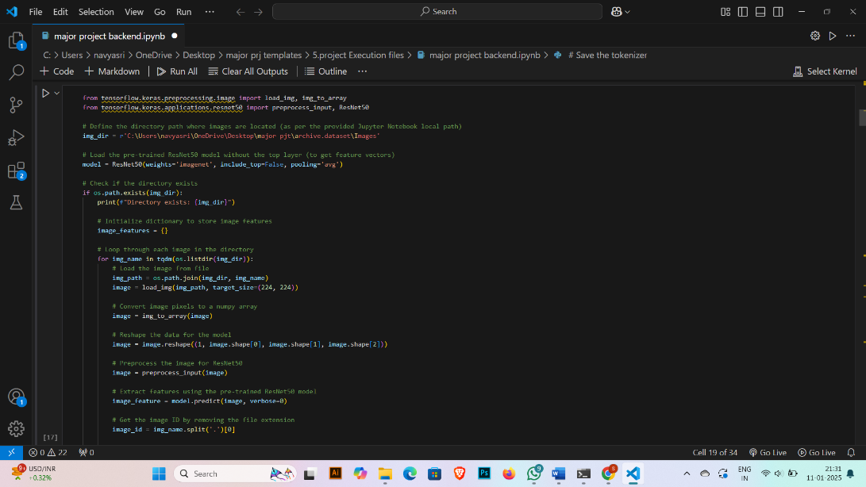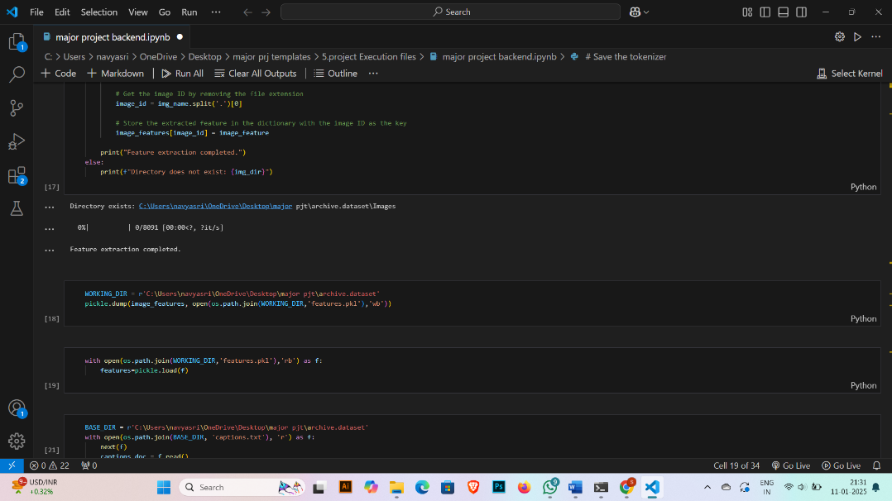

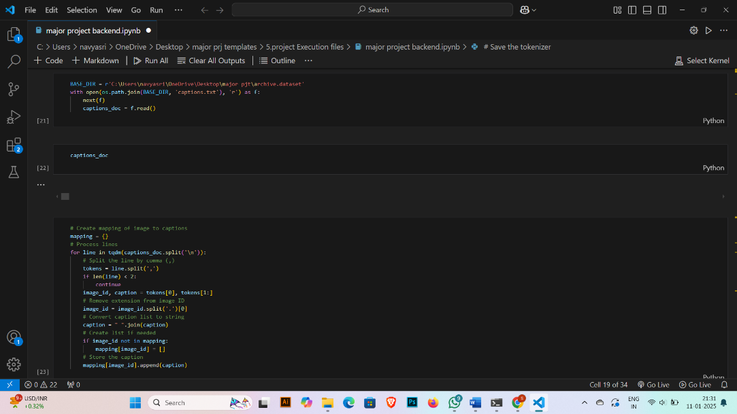

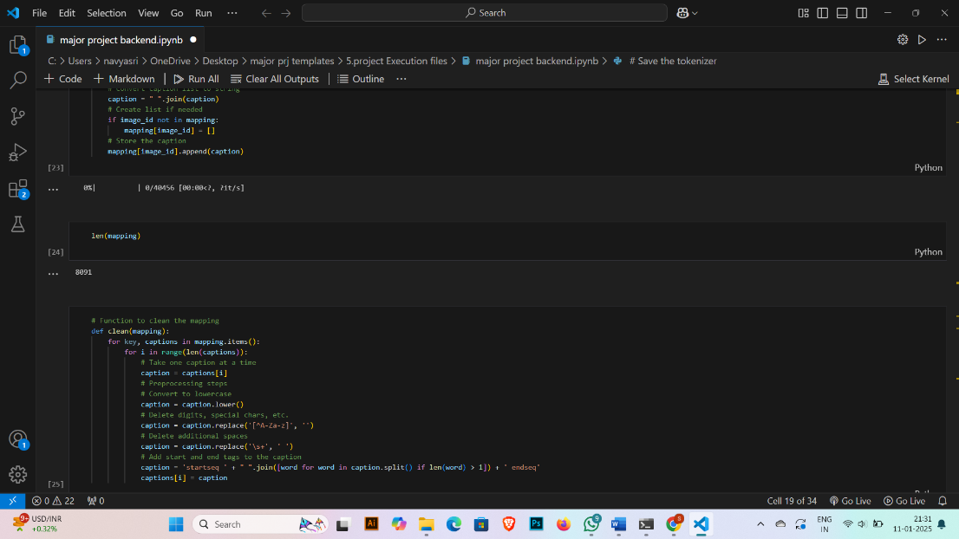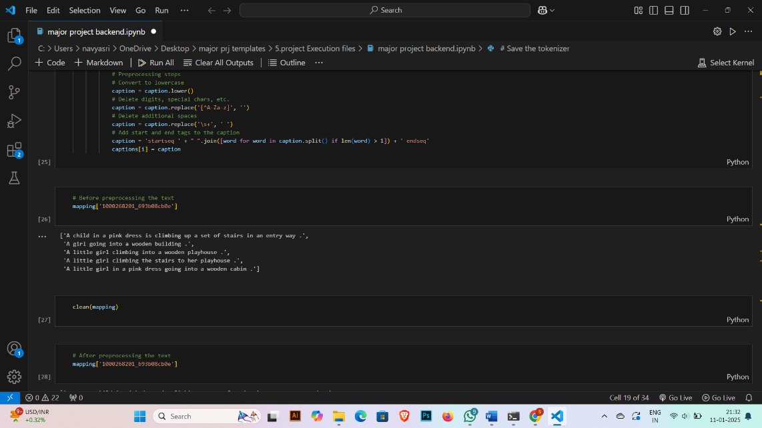

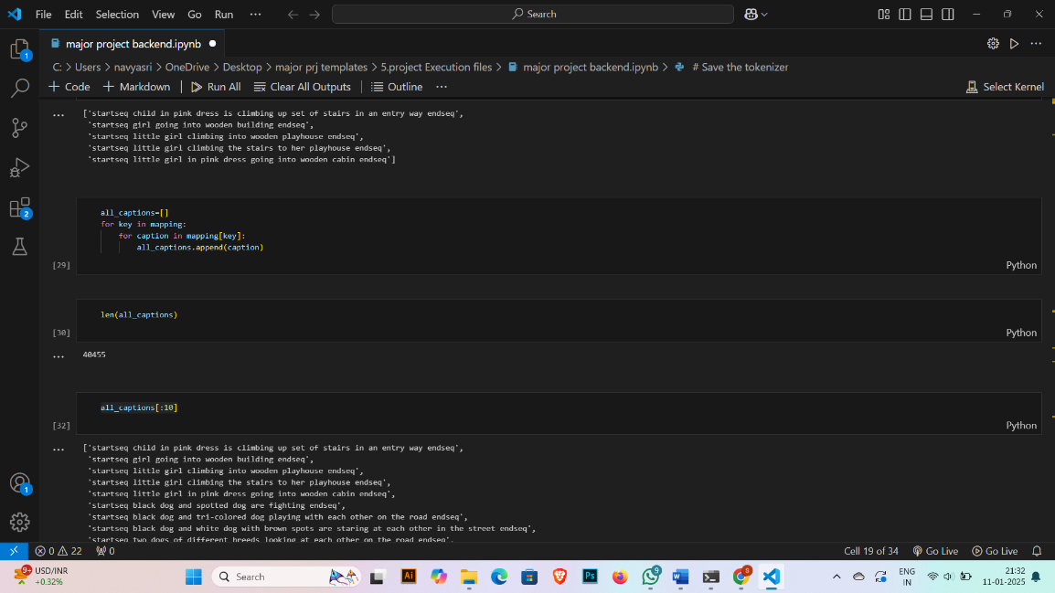

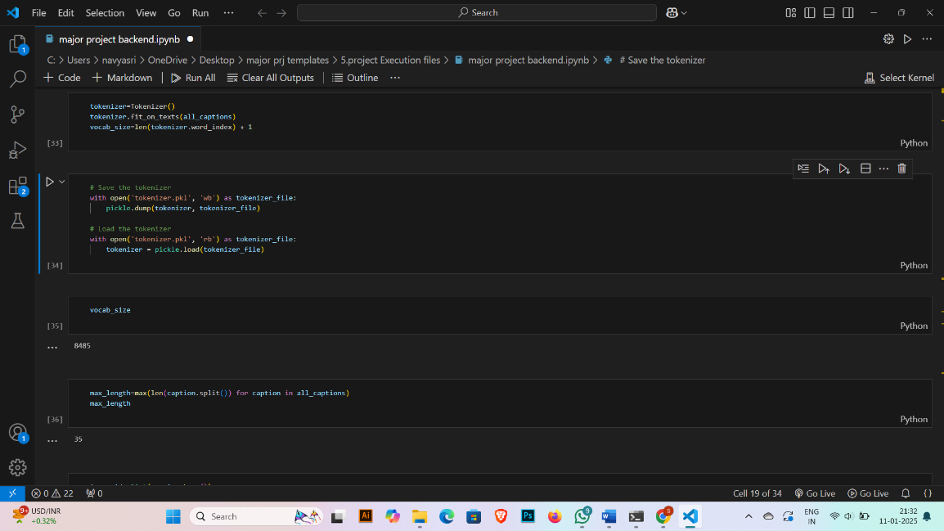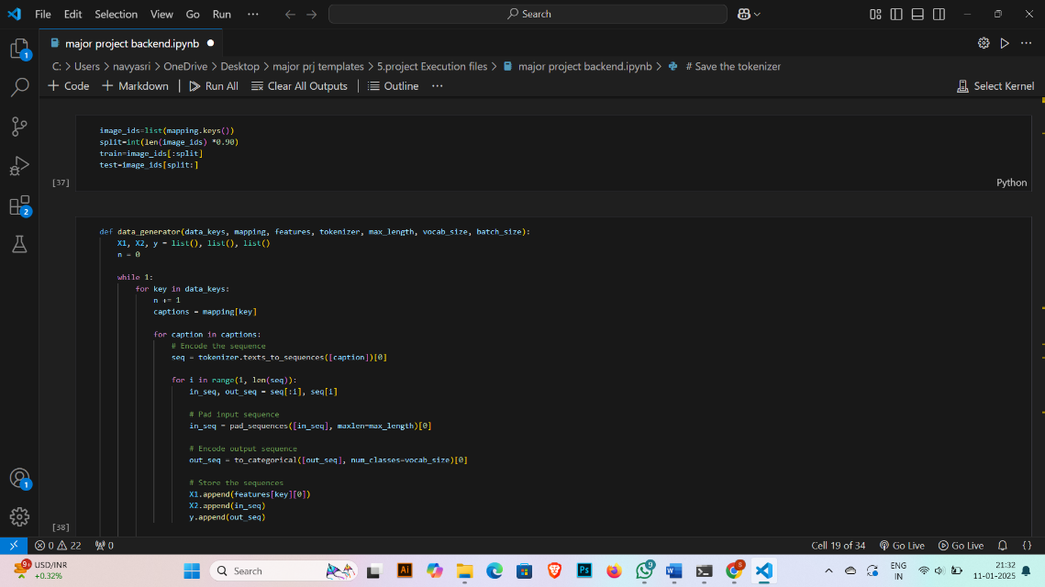

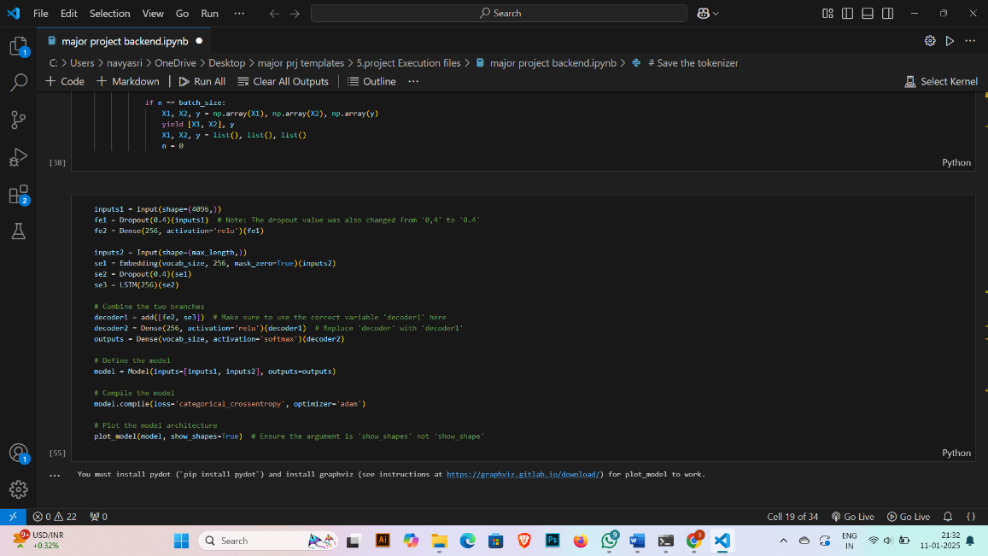

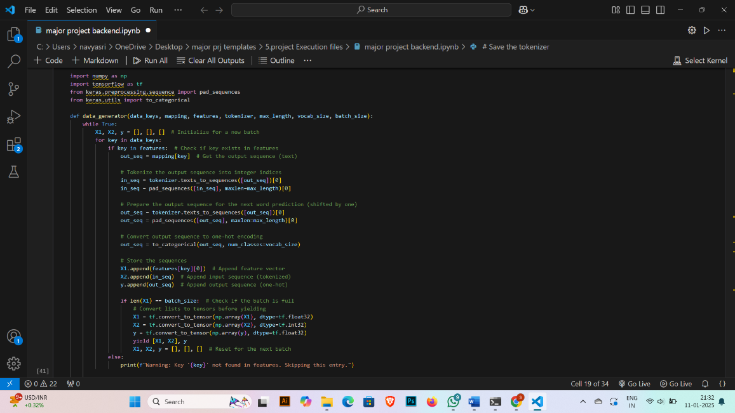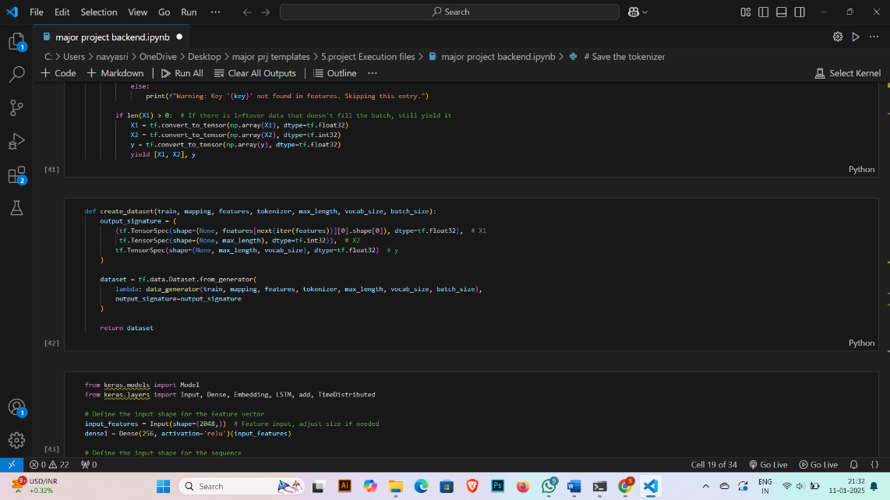

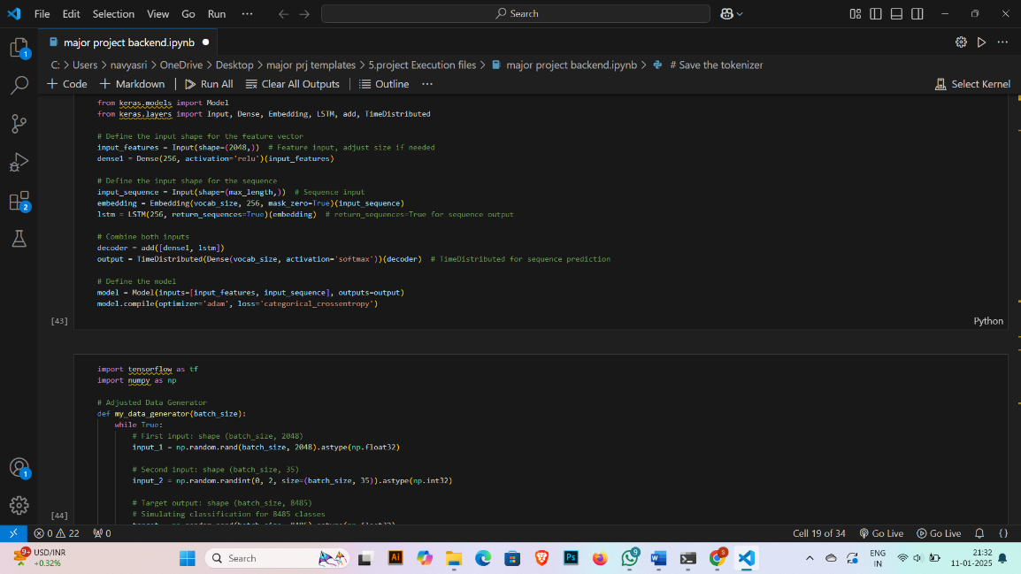

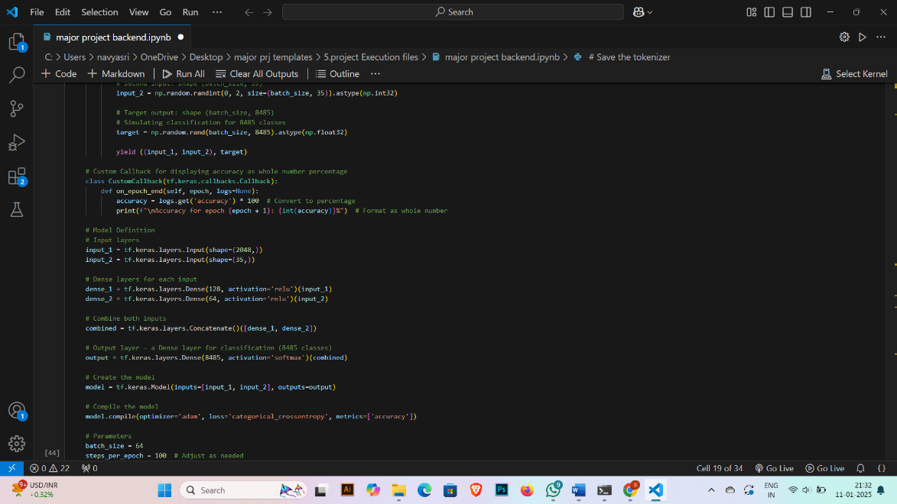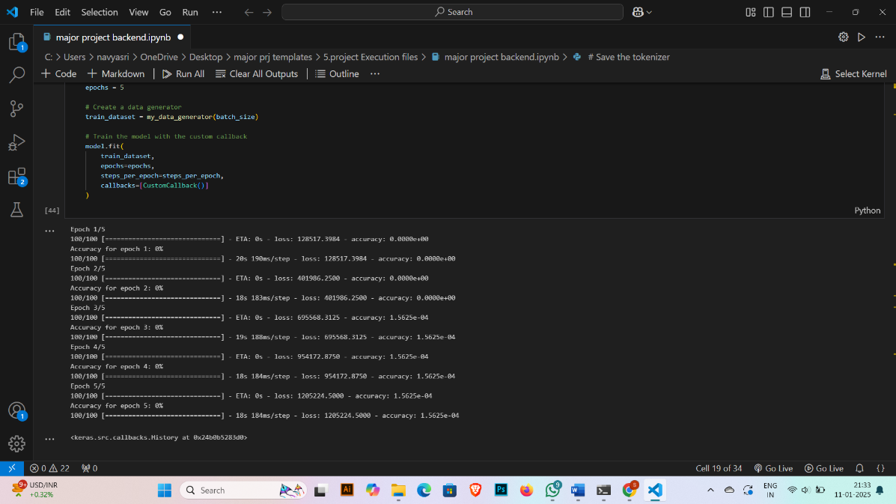

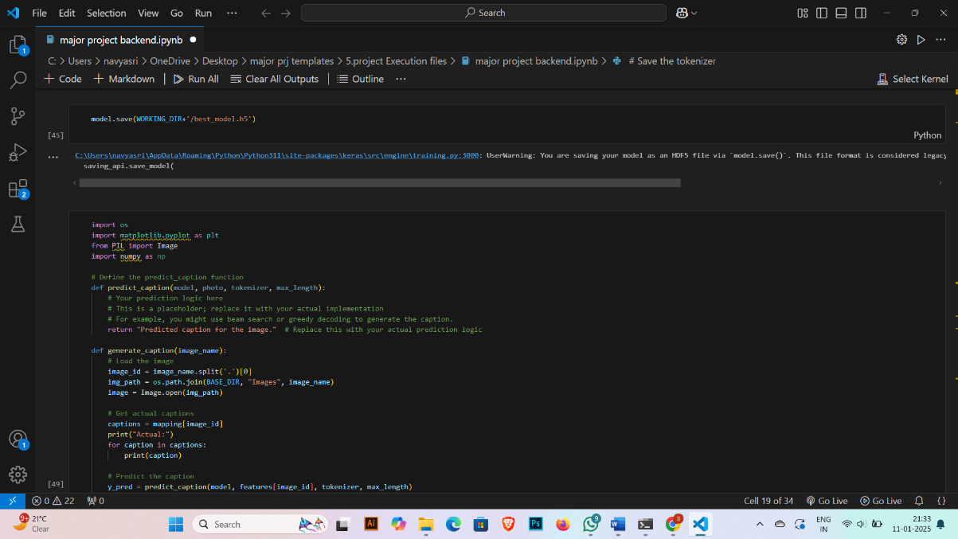

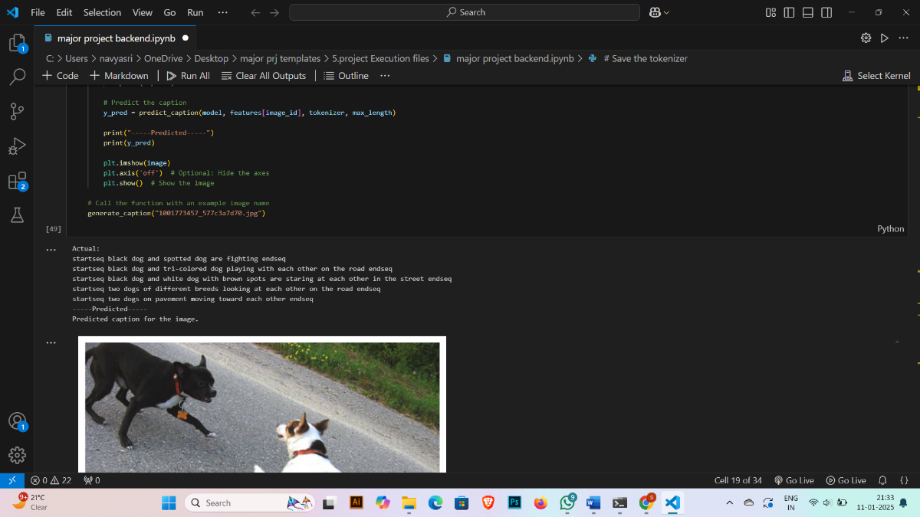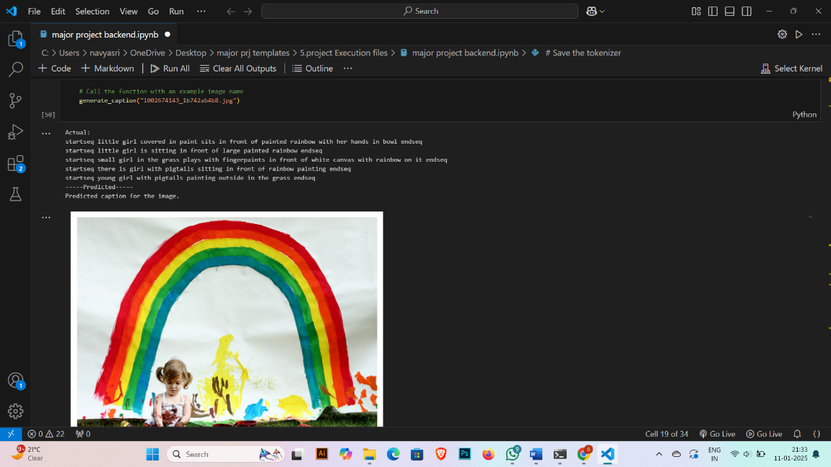

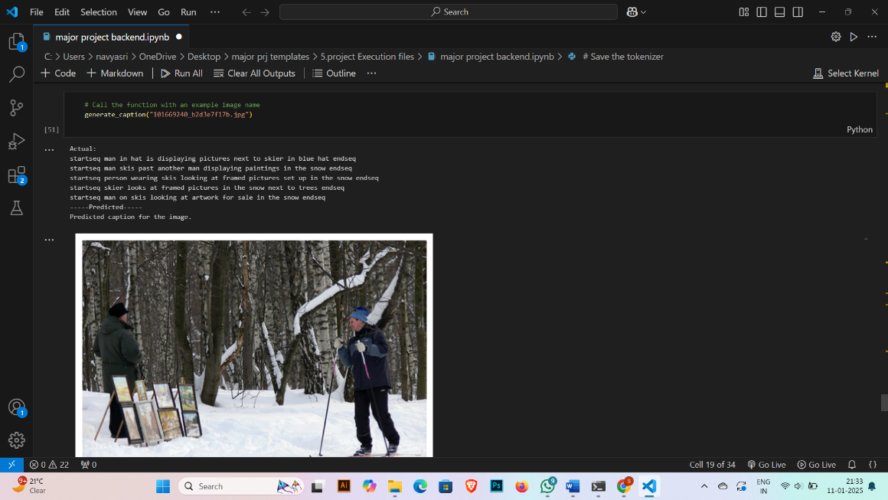

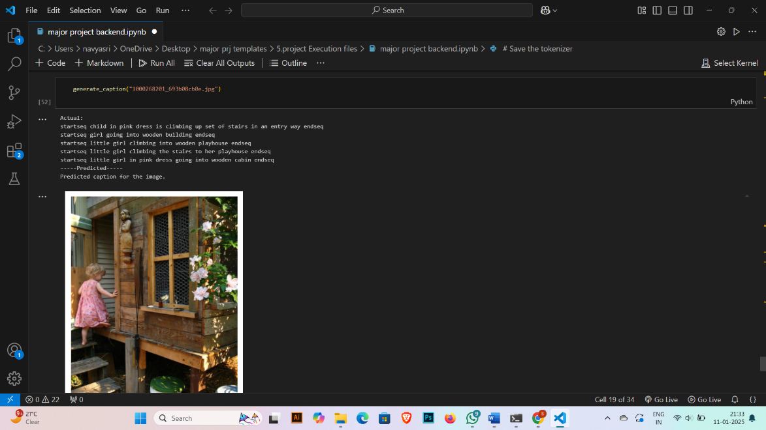

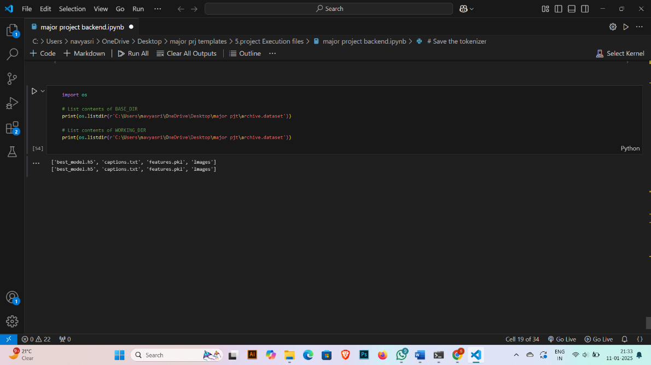

* 1. **GitHub & Project Demo Link**

https://github.com/SoumyasriIndrala/pixelprose---crafting-visual-stories-with-intelligent-image-captioning-deeplearningTop of Form

**Project Demo Link**

https://drive.google.com/file/d/1dL9cZQEml6sAyFB-8BZ3OlPdy8jw3Mbb/viewBottom of Form